

**Database Management System**

**CSE303**

Air Quality Monitoring System (AQMS)

Final Report

Group 04

Section 03

**Student Name ID**

Mushfiqur Alam Bhuiyan 2020301

Toushif Hossain 1920404

Azwad Fawad Hasan 2020222

Tanjina Sikder Tonny 1931150

Seeyam Akhter 1920181

Md. Al-Abid Supto 1921719

Table Contents

**CHAPTER 1: INTRODUCTION** 3

**SECTION 1.1: BACKGROUND OF THE ORGANIZATION** 3

**SECTION 1.2: BACKGROUND OF THE PROJECT** 3

**SECTION 1.3: OBJECTIVES OF THE PROJECT** 3

**SECTION 1.4: SCOPE OF THE PROJECT** 3

**CHAPTER 2: REQUIREMENT ANALYSIS** 4

**SECTION 2.1: RICH PICTURE (EXISTING)** 4

**SECTION 2.2: SIX ELEMENTS SYSTEM ANALYSIS (EXISTING)** 5

**SECTION 2.3: PROCESS DIAGRAM (EXISTING)** 13

**SECTION 2.4: EXISTING PROBLEMS & ANALYSIS OF THE PROBLEM** 15

**SECTION 2.5: RICH PICTURE (PROPOSED)** 16

**SECTION 2.6: SIX ELEMENT SYSTEM ANALYSIS (PROPOSED)** 17

**SECTION 2.7: PROCESS DIAGRAM (PROPOSED)** 20

**CHAPTER 3: LOGICAL SYSTEM DESIGN** 22

**SECTION 3.1: BUSINESS RULES** 22

**SECTION 3.2: EERD** 23

**SECTION 3.3: EERD TO RELATIONS** 24

**SECTION 3.4: NORMALIZATION** 25

**SECTION 3.5: DATA DICTIONARY** 28

**CHAPTER 4: PHYSICAL SYSTEM DESIGN** 37

**SECTION 4.1: INPUT FORMS** 37

**SECTION 4.2: OUTPUT FORMS** 40

**CHAPTER 5: CONCLUSION** 51

**SECTION 5.1: PROBLEM AND SOLUTION** 51

**SECTION 5.2: ADDITIONAL FEATURE AND FUTURE DEVELOPMENT** 51

**SECTION 5.3: CONCLUSIONS AND RECOMMENDATIONS** 52

# **CHAPTER 1: INTRODUCTION**

## **SECTION 1.1: BACKGROUND OF THE ORGANIZATION**

An Air Quality Monitoring System (AQMS) is a system that measures meteorological parameters such as wind speed, wind direction, rainfall, radiation, temperature, barometric pressure and ambient parameters. The AQMS also integrates a series of ambient analyzers to monitor the concentration of air pollutants (such as SO2, NOx, CO, O3, THC, PM, etc.) continuously. HORIBA also provides mobile monitoring stations that can be used to monitor ambient conditions at multiple sites.

## **SECTION 1.2: BACKGROUND OF THE PROJECT**

In this project, we suggest creating a data-driven software system for tracking the air quality of Bangladesh. The proposed AQM system's primary goals are to raise air quality and create a low-cost method of raising AQI data. The goal of this project is to develop an automated system that can gather data input from stakeholders, validate the data, and produce graphics. Our system provides solutions to some of the major challenges encountered in remote environmental monitoring applications like outdoor air quality monitoring system.

## **SECTION 1.3: OBJECTIVES OF THE PROJECT**

The main objective of this project is to create an automated system which can automatically take data input provided by stakeholders and verify the data & generate charts.

Our proposed system will provide atmospheric maps and charts for monitoring the current and future Air Quality Index (AQI) of any area. The overall air quality and other pollutant data will be calculated and displayed in the form of atmospheric maps and charts which will help the decision-makers to analyze air quality and to take initiatives for improving the air quality.

In our proposed system user interfaces will be available so that users can observe the data with respect to different times.

## **SECTION 1.4: SCOPE OF THE PROJECT**

To ensure a project's success, the scope of the project must be defined. We must ensure that the  
proposed system is much more efficient.

We are working to improve some of the below primary functionalities:

* Keeping the data in a relational data base manner
* Securing the data by restricting system access
* Insert, update, and delete data from a database without inconsistency
* Creating reports instantly
* Generate charts from the given data

# **CHAPTER 2: REQUIREMENT ANALYSIS**

## **SECTION 2.1: RICH PICTURE (EXISTING)**

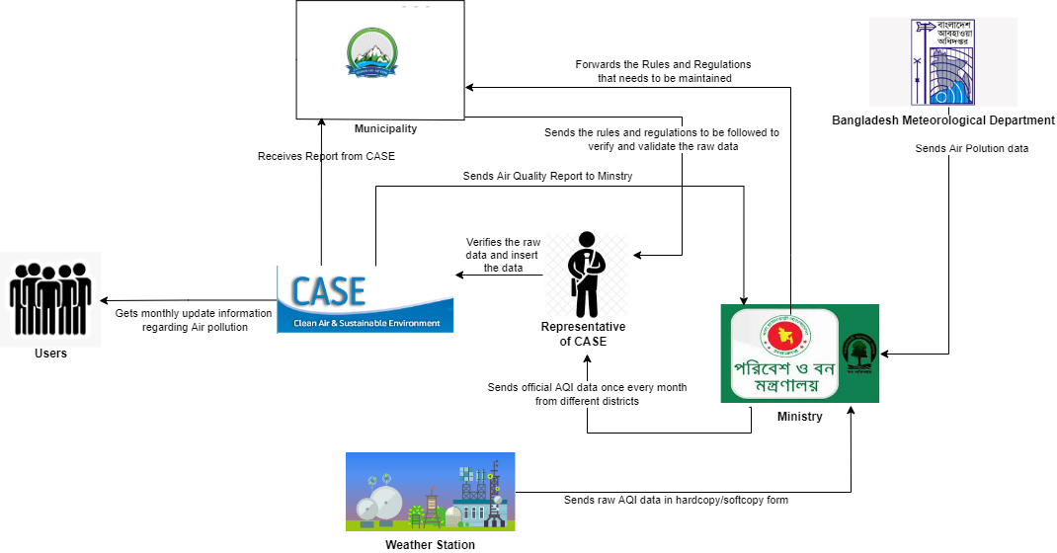

Figure 2.1: Rich Picture (Existing)

## **SECTION 2.2: SIX ELEMENTS SYSTEM ANALYSIS (EXISTING)**

|  |  |  |  |  |  |  |
| --- | --- | --- | --- | --- | --- | --- |
| **Process** | **System Roles** | | | | | |
| **Human** | **Non-Computing Hardware** | **Computing Hardware** | **Software** | **Database** | **Network & Communication** |
| **Insert AQI Data** | **Bangladesh Meteorological Department:**   1. Collects the air pollution data and sends it to the ministry.   **Weather Station:**   1. Collects AQI data from the sensors and satellites and sends these raw AQI data to the ministry in hardcopy or softcopy form.   **Ministry:**   1. Receives the air pollution data from Bangladesh meteorological department in hardcopy or softcopy form. 2. Receives the raw AQI data from the weather station which was taken from different sensors and satellites in hardcopy or softcopy form. 3. Accumulates all the AQI data of each month from the ministry and sends these AQI data to the representative of CASE in hardcopy or softcopy form once every month.   **Representative of CASE:**   1. Receives the monthly AQI data from the ministry and then inserts this data into the database of CASE.   **Internal IT Expert:**   1. The IT experts make sure the data is protected in the CASE system.      1. They must make sure the website is always running. 2. They keep a backup ready in case of power failures.   **External IT Expert:**   1. Server providers manages the network resources so that any user of the CASE system can access the system from anywhere in the world. 2. The internet service providers provides internet connection to the representative of CASE to do their data entry. | **Paper and stationery:**   1. Stationary used to update on the data sheet by the workers collecting the raw data. 2. Bangladesh meteorological department and weather station can use papers to manually send the data to the ministry. 3. Ministry can use paper for printing purpose to keep a manual database. 4. Ministry can use paper to manually send the data to the representative of CASE.   **Data Sheet in Printed Version:**   1. The data sheet can be used by Bangladesh meteorological department and weather station to collect the data from the satellite and sensors.   **Cabinets:**   1. Cabinets used to store the Register Books or Data sheets prepared by the Data sourcing departments and the ministry.   **File Holder:**   1. To hold the data sheet prepared by the Bangladesh meteorological department and weather stations. | **PC/ Laptop/ Other computing device:**   1. Computers, mouse, keyboards and any other computing devices are used by all the users of CASE in order to input and select data.   **Printer:**   1. Printers are used by all the users in order to print the AQI data sheet.   **Servers:**   1. Database servers used by CASE for the representative of CASE for data entries.   **Router/ Internet Cables by ISP Providers/ Switch**:   1. From networking side, internet cables by the ISP providers or router or switch used by the users of CASE.   **Pen drive:**   1. This is used as another medium by the users of CASE to pass the data. | **CASE:**   1. It is an interface which stores data and is used by the users of CASE for data entries.   **Operating System:**   1. Any Operating system can be used by the representative of CASE like Windows, Mac or Linux.   **Application Software:**   1. Application software used by Bangladesh meteorological department, ministry and weather station like MS Excel, MS Word.   **Web Based Application Software:**   1. Bangladesh meteorological department and weather station may use application software to collect data from sources.   **Printing Software:**   1. To print the data sheets, a printing software is needed by Bangladesh meteorological department, weather station and ministry. | **MySQL**:   1. The representative of CASE can also use database system like MySQL to store the raw data.   **MS Excel Files:**   1. Data can be stored in MS Excel files.   **Register Book or Log Files:**   1. Bangladesh Meteorological department, weather station and ministry can use register book or log files in order to manually store data.   **Database System of CASE:**   1. Representative of CASE can use the database system of CASE in order to input and update data. | **Internet:**   1. Internet is required in order to input or update the data by the representative of CASE in the database of CASE.   **Mails:**   1. Mails can be exchanged among the users of CASE in order to communicate about the data entries. |
| **Verification & validation of Data** | **Ministry:**   1. By analyzing the previous month reports, they send rules and regulation that needs to be maintained in order to get better quality air in the cities.   **Municipality:**   1. Receives the rules and regulation from the ministry that needs to be maintained. 2. Delivers the rules and regulation to the representative of CASE which needs to be followed by the representative of CASE in order to verify and validate the raw AQI data.   **Representative of CASE:**   1. After receiving the accumulated data of the month from the ministry and the rules from the municipality, the representative of CASE verifies and validates the raw data and then inserts the data into the database of CASE.   **Internal IT Expert:**   1. The IT experts make sure the data is always protected in the CASE system. 2. They must make sure the website is always running. 3. They have a backup ready in case of power failures as well.   **External IT Expert**:   1. Server providers manages the network resources so that representative of CASE system can view, verify and update the data from anywhere in the world. 2. The internet service providers provides internet connection to the representative of CASE to view, verify and update the data entries. | **Paper and stationery:**   1. Paper can be used by the ministry and municipality to print the rules and regulations. 2. Stationery used by ministry and municipality in order to set the rules and regulations and also to sign and validate the data. 3. Representative of CASE use stationery to verify, update and validate the data by signature.   **Printed Version:**   1. Representative of CASE may print the before and after verification data sheets in order to keep a manual database.   **Cabinet:**   1. To store the data sheet before and after the verification process as a manual database.   **File Holder:**   1. To hold the data sheet after the verification process as a manual database. | **PC/ Laptop/ Other Computing Device:**   1. Representative of CASE uses computing device in order to view, verify and update the data in the database system of CASE. 2. Data can be stored in a computer as backup. 3. Municipality and ministry uses computer in order to set the rules and regulations that needs to be maintained.   **Printer:**   1. Municipality and ministry uses printer in order to print the rules and regulation in a paper and pass it forward.   **Routers/ Internet Cables by ISP Providers/ Switch:**   1. From networking side, internet cables by the ISP providers or router or switch used by the users of CASE. | **CASE:**   1. The CASE system is used by the representative of CASE to access the data provided by the data sources for reviewing. 2. It is used to input the verified data. 3. It is used to update the data if required.   **Operating System:**   1. Any operating system can be used by the representative of CASE and the policy makers like Windows, Mac and Linux.   **Web-based Application Software:**   1. The representative of CASE will use browsers to visit CASE and input data. | **MySQL**:   1. The representative of CASE can also use database system like MySQL to store the raw data after verification.   **MS Excel Files:**   1. Data can be stored after verification in MS Excel files.   **Register Book or Log Files:**   1. After verification, data can be stored in register or log files to maintain a manual database.   **Database System of CASE:**  Representative of CASE can use the database system of CASE in order to input and update data after verification. | **Internet:**   1. Internet is required in order to input or update the data after verification by the representative of CASE in the database of CASE.   **Mails:**   1. Mails can be exchanged among municipality, ministry and the representative of CASE in order to communicate about the data entries. |
| **Report Generation & Analyzing** | **Representative of CASE:**   1. From the AQI data received from the ministry every month, the representative of CASE generates reports and upload it in the database of CASE, which is shown on the website of CASE.   **Ministry:**   1. Can view and download the air pollution report from the website of CASE, which is later analyzed and new rules and regulations can be sent to the Municipality which needs to be maintained.   **Municipality:**   1. Can view and download the monthly report from the website of CASE and then analyze those reports for further new plans.   **User:**   1. Can view and download the report from the website of CASE and get information about the country’s air quality.   **Internal IT Expert:**   1. Creates the report template creating and editing module in the CASE system for the representative of CASE, so that they can create and edit templates if required. 2. Maintains the CASE system so that if there is any problem they can fix that.   **External IT Expert:**   1. Server providers in the CASE system manages network resources so that the data can be viewed, report can be generated and uploaded by the representative of CASE. 2. The internet service providers provide internet connection to municipality, ministry and the representative of CASE in order to make new policies after analyzing the report and to upload the reports generated. | **Paper and stationery:**   1. Paper can be used by the ministry, municipality and user to print the generated report from CASE. 2. Stationery is used by ministry and municipality in order to analyze the report and make new set of rules and regulations.   **Printed Version:**   1. Ministry, municipality and user may download and print the reports to analyze.   **Cabinet:**   1. To store the monthly reports in printed version.   **File Holder:**  To hold the data sheet after the verification process as a manual database. | **PC/ Laptop/ Other Computing Device:**   1. Representative of CASE requires computing device in order to upload the generated report in the database of CASE. 2. Representative of CASE requires computing device to make changes in the template of the report, if required.   **Printer:**   1. Municipality, ministry and user uses printer in order to print the monthly reports of the areas of Bangladesh.   **Routers/ Internet Cables by ISP Providers/ Switch:**   1. From networking side, internet cables by the ISP providers or router or switch used by the users of CASE. | **CASE:**   1. It is used to upload the reports by the representative of CASE. 2. It is used by ministry, municipality and user to download and analyze the reports.   **Operating System:**   1. Any operating system can be used by the representative of CASE, the policy makers and users like Windows, Mac and Linux.   **Web-based Application Software:**   1. The representative of CASE will use browsers to visit CASE and input data.   **Application Software:**   1. The graphs in the report are generated using MS Excel by the representative of CASE. 2. The report template are created in MS Word. | **MySQL**:   1. The representative of CASE can also use database system like MySQL to store the monthly reports after generating those.   **Database System of CASE:**   1. Representative of CASE can use the database system of CASE in order to upload the reports.   **HDD:**   1. The downloaded reports can be stored in a hard disk for backup. | **Internet:**   1. Internet is required in order to upload reports by the representative of CASE in the database of CASE. 2. Internet is required in order to access the website of CASE to view or download the monthly AQI reports.   **Mails:**   1. Mails can be exchanged among municipality, ministry and the representative of CASE in order to communicate during the analyzing of the reports. |

## **SECTION 2.3: PROCESS DIAGRAM (EXISTING)**

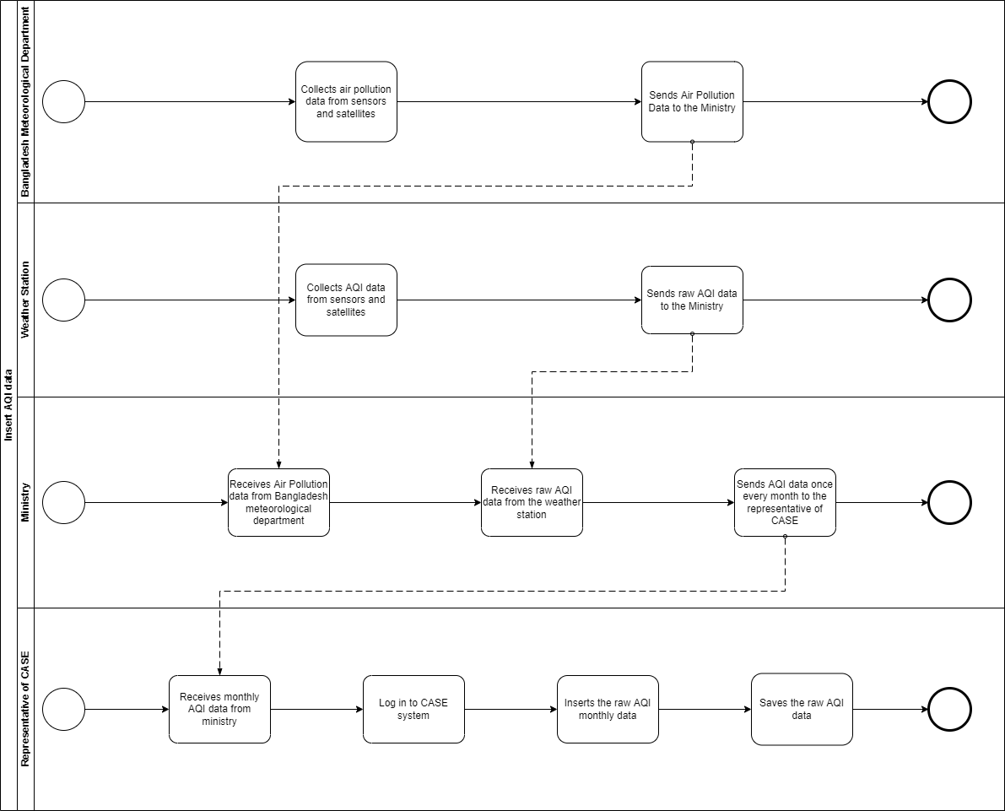

Figure 2.2: Business Process Diagram for Insertion of AQI Data (Existing)

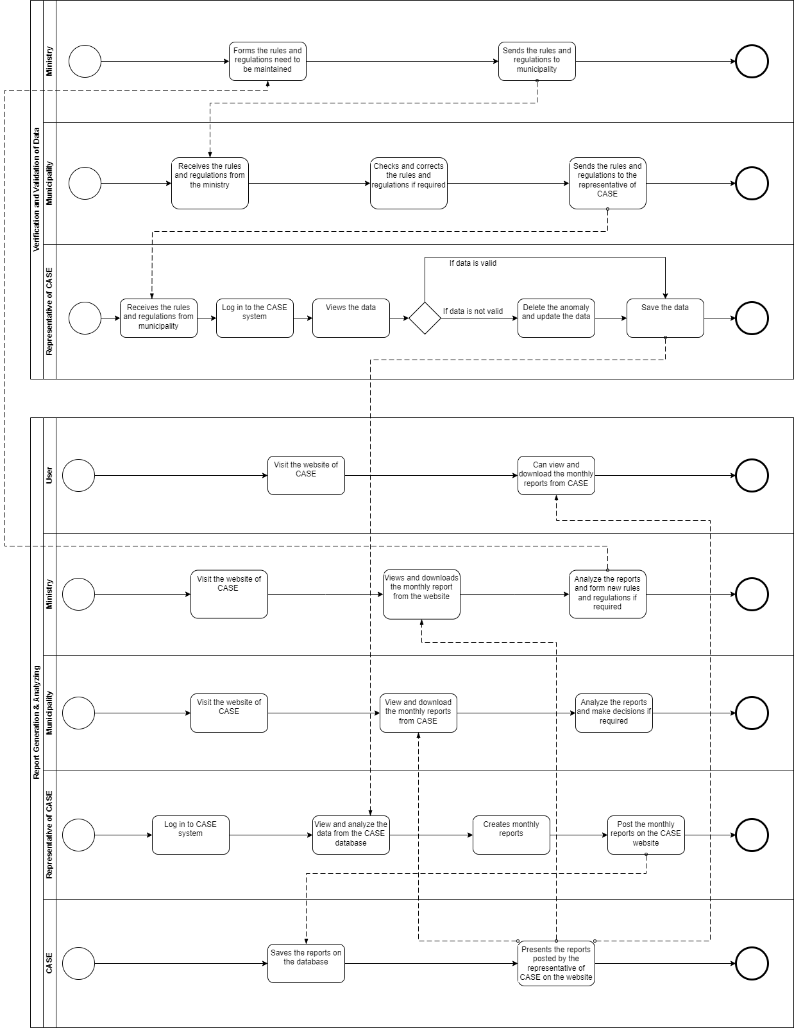

Figure 2.3: Business Process Diagram for Verifying and Update and Report Generation and Analyzing

## **SECTION 2.4: EXISTING PROBLEMS & ANALYSIS OF THE PROBLEM**

|  |  |  |  |  |
| --- | --- | --- | --- | --- |
| **Process Name** | **Stakeholders** | **Concerns**  **(Issues/Problems)** | **Analysis**  **(Reason of the Problems)** | **Proposed Solution** |
| **Data Entry** | 1. **Representative of CASE** 2. **Data providers (BMD, Ministry, Weather Station)** | 1. Takes longer time to gather data(s) | 1. As data is collected from different sources and there are huge number of data to process to it becomes very time consuming | 1. Re-build the database in a way so that the stakeholders can input their own data directly and generate reports. It will help stakeholders to input and access data easily. Thus, it’ll decrease data entry delay. |
| **Verifying data** | 1. **Representative of CASE** | 1. Manual checking 2. No verification and validity of data | 1. All the data is checked manually and it becomes very time consuming | 1. Build an in-built module that will check the input data from stakeholders, which will eliminate manual checking. |

## **SECTION 2.5: RICH PICTURE (PROPOSED)**

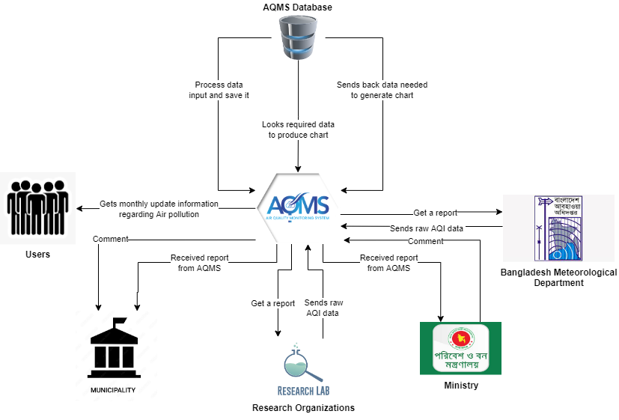

Figure 2.4: Rich Picture (Proposed)

## **SECTION 2.6: SIX ELEMENT SYSTEM ANALYSIS (PROPOSED)**

|  |  |  |  |  |  |  |
| --- | --- | --- | --- | --- | --- | --- |
| **Process** | **System Roles** | | | | | |
| **Human** | **Non-Computing Hardware** | **Computing Hardware** | **Software** | **Database** | **Network & Communication** |
| **Data Insertion** | **AQMS:**   1. Receives raw data from research lab. 2. Collects raw AQI data from BMD. 3. Receives comment from Municipality and Ministry. 4. Receives generated chart from the database.   **Research Lab:**   1. Collects report from AQMS.   **Ministry:**   1. Receives report from AQMS.   **Bangladesh Meteorological Department:**   1. Receives report from AQMS.   **Municipality:**   1. Receives final report from AQMS.   **Representative of AQMS:**   1. Receives the monthly AQI data from the ministry and then inserts this data into the database of AQMS. | **Pen and Papers:**   1. To   Collect manual data for the hardcopy.   1. Stationary used to update on the data sheet by the workers collecting the raw data.   **PDF:**   1. The data report   can be viewed on a  PDF format.  **Data Sheet in Printed Version:**   1. The data sheet can be collected as a printed version from the data sources. | **Computer:**   1. All the data are finally stored using a computer.   **Smartphone:**   1. AQMS can be accessed through any smartphone.   **Printer**   1. Printers used to print the datasheet.   **Scanner**   1. Scanners to scan the data.   **Router/**  **Internet Cables**  **by ISP**  **Providers/**  **Switch** | **Operating**  **System:**  1. Any Operating System used  like Mac,  Windows, Linux.  **Application**  **Software:**  1. Application  software  like MS  Excel,Chrome;  Safari;  Firefox  etc**.**  **Printing**  **Software:**  To print the data sheets, a printing software is needed by Bangladesh meteorological department, weather station and ministry. | **Database System of AQMS**   1. Collection of data is updated into a database system of AQMS.   **MS Excel files:**   1. MS Excel files can be used to store the data.   **MySQL:**   1. Database system like   MySQL to store the raw data. | **Internet:**   1. Used to access the system. 2. Internet is   used to validate  the forms and  reports.  **Mail:**   1. Mail is used to transfer data. 2. Mails can be exchanged among the users of AQMS in order to communicate about the data entries. |
| **Data Analysis and Data Update** | **AQMS:**   1. Process data and send required data to regenerate the chart.   **Municipality:**   1. After analyzing the received data from AQMS, sends a comment back to AQMS.   **Research Lab:**   1. Analyze the raw data and sends a report to AQMS.   **Representative of AQMS:**   1. The AQMS representative examines and validates the raw data after receiving the tallied data for the month from the ministry and the rules from the municipality, and then enters the data into the AQMS database. | **Not Applicable** | **Computer:**   1. All the data are finally stored using a computer.   **Smartphone:**   1. AQMS can be accessed through any smartphone.   **Printer**   1. Printers used to print the datasheet.   **Scanner**   1. Scanners to scan the data.   **Router/**  **Internet Cables**  **by ISP**  **Providers/**  **Switch** | **Operating**  **System:**   1. Any Operating System used like Mac,   Windows, Linux.  **Application**  **Software**   1. Application software like MS Excel,Chrome; Safari, Firefoxetc**.**   **Printing**  **Software:**   1. To print the data sheets, a printing software is needed by Bangladesh meteorological department, weather station and ministry. | **Database System of AQMS**   1. Collection of data is updated into a database system of AQMS.   **MS Excel files:**   1. MS Excel files can be used to store the data.   **MySQL:**   1. Database system like MySQL to store the raw data. | **Internet:**   1. Used to access the system. 2. Internet is   used to validate  the forms and  reports  **Mail:**   1. Mail is used to transfer data. 2. Mails can be exchanged among municipality, ministry and the representative of AQMS in order to communicate about the data entries. |
| **Output** | **User:**   1. Gets monthly updated information regarding air pollution. | **Not Applicable** | **Smartphone:**   1. AQMS can be accessed through any smartphone.   **PC/ Laptop/ Computer:**   1. AQMS can be accessed through computer. | **Operating**  **System:**   1. Any Operating System used by   the data  sourcing team  and  Users like Mac,  Windows, Linux.  **Application**  **Software:**   1. Application   software  like MS  Excel,Chrome;  Safari;  Firefoxetc**.**  **Printing**  **Software:**   1. To print the data sheets, a printing software is needed by Bangladesh meteorological department, weather station and ministry. | **MySQL:**   1. Database system like   MySQL to store the raw data. | **Internet:**   1. Used to access the system. 2. Internet is   used to validate  the forms and  reports  **Mail:**   1. Mail is used to transfer data. 2. Mails can be exchanged among municipality, ministry and the representative of AQMS in order to communicate about the data entries. |

## **SECTION 2.7: PROCESS DIAGRAM (PROPOSED)**

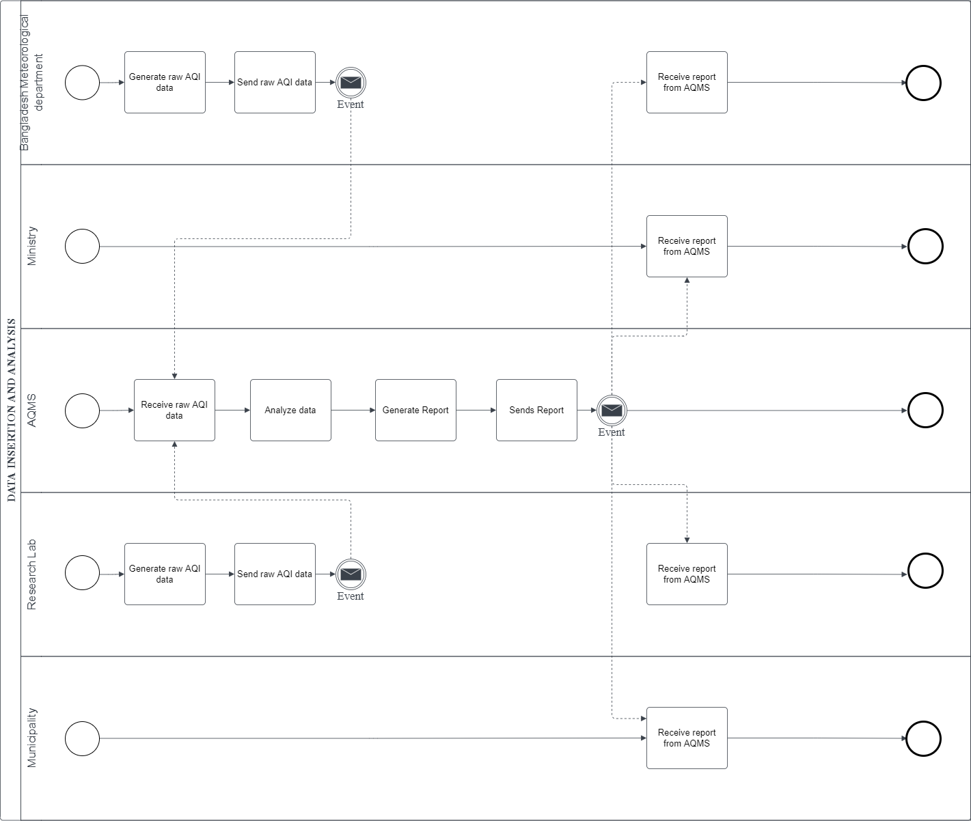

Figure 2.5: Business Process Diagram for Data Insertion and Analysis (Proposed)

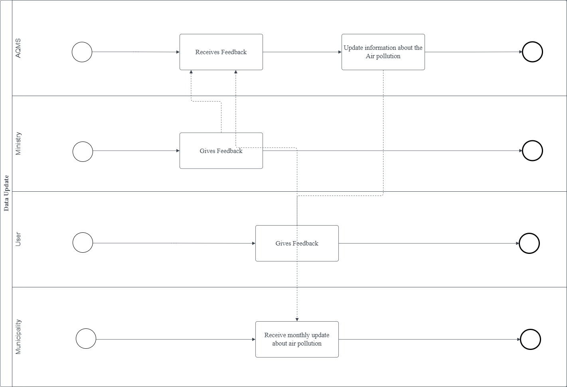

Figure 2.6: Business Process Diagram for Data Update (Proposed)

# **CHAPTER 3: LOGICAL SYSTEM DESIGN**

## **SECTION 3.1: BUSINESS RULES**

Business rules are statements that impose some form of constraint on a specific aspect of the database, such as the elements within a field specification for a particular field or the characteristics of a given relationship. A business rule is based on the way the organization perceives and uses its data, which is determined from the manner in which the organization functions or conducts its business.

1. Municipality may view multiple policies; however, policy comments can be viewed by only one municipality. Municipality can be identified by municipality id. It also has a name, location, division, and district and headquarter.
2. Policy comment has policy comment id, which user posted it and at what time it is posted, also it has comments posted by the users.
3. Ministry can be identified by Ministry id. It also has name, email & website address. Ministry can post multiple comments on policies but it will be posted by only one ministry.
4. AQMS user has user id, their name, email address & their date of birth. Also, it has their organization details and designation. AQMS users can receive multiple reports from the municipality but only one report from ministry. Reports will be received by only one user of the AQMS. AQMS user can receive multiple AQI data from organization but will be received my only one user.
5. Organization has unique id. There are two types of organization: private research lab & metrological department. Research lab & metrological department both has unique id(s). Research lab has location & certification. Meteorological department has station id and division.
6. Organization contains multiple organization data which includes: date, latitude, longitude, mean, median, max, sum, count, PM25, average temperature, rain precipitation, wind speed, visibility, cloud cover, relative humidity, division and season.

## **SECTION 3.2: EERD**

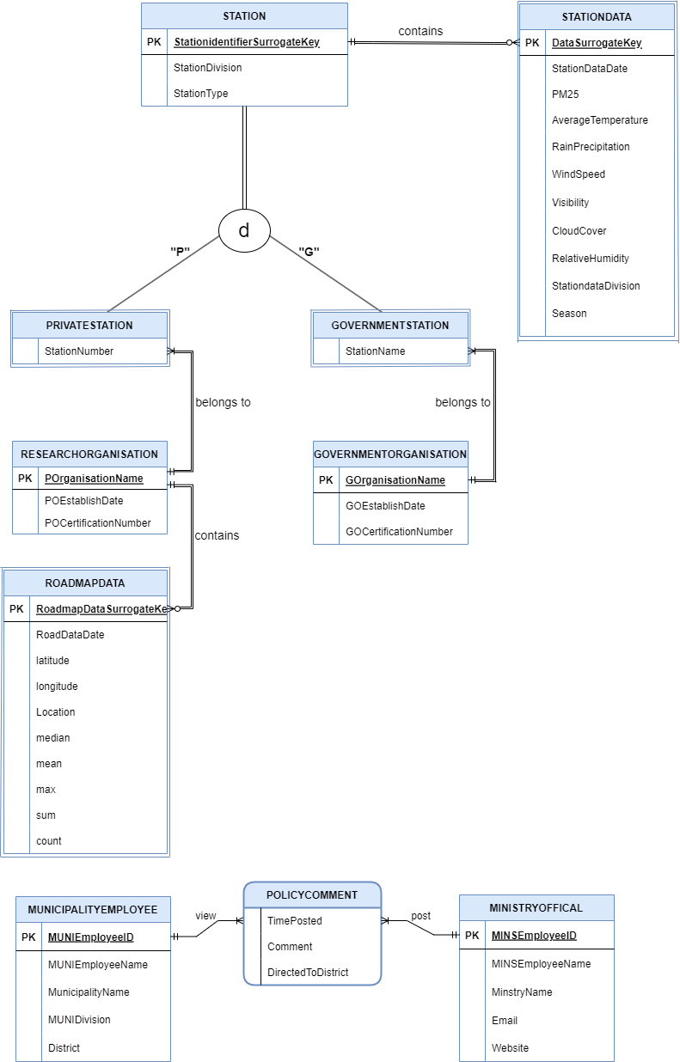

Figure 3.1: Extended Entity Relationship Diagram for the AQM system

## **SECTION 3.3: EERD TO RELATIONS**

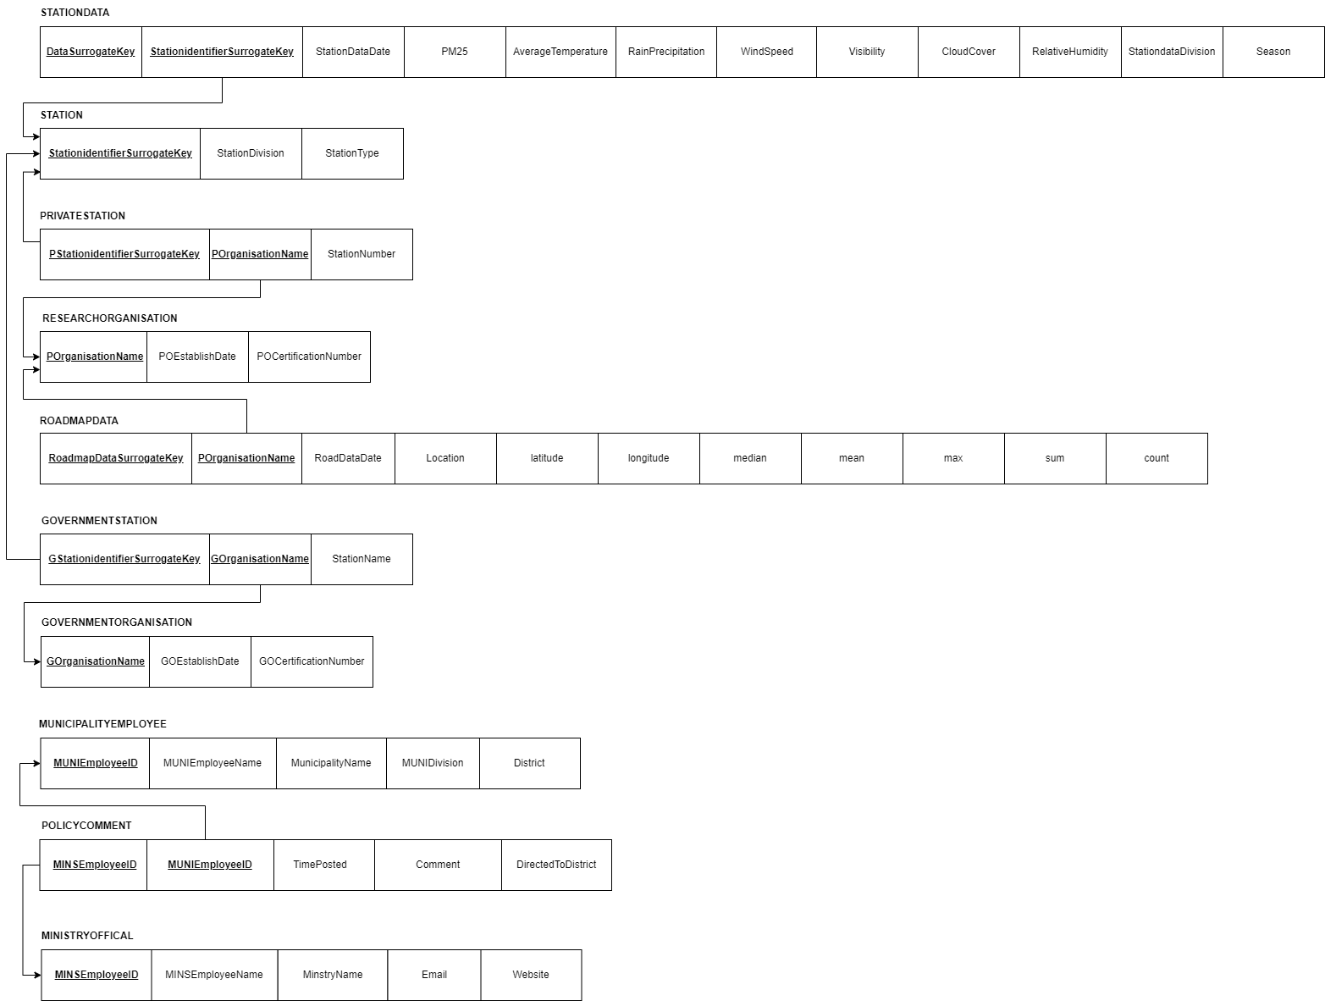

Figure 3.2: Relation Schema of the AQM system

## **SECTION 3.4: NORMALIZATION**

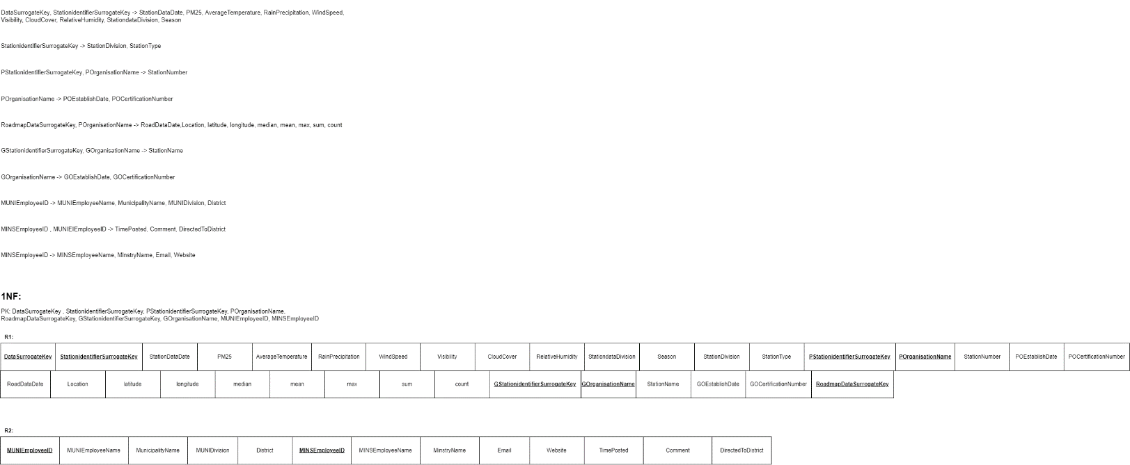

Figure 3.3: Normalization (till 1NF)

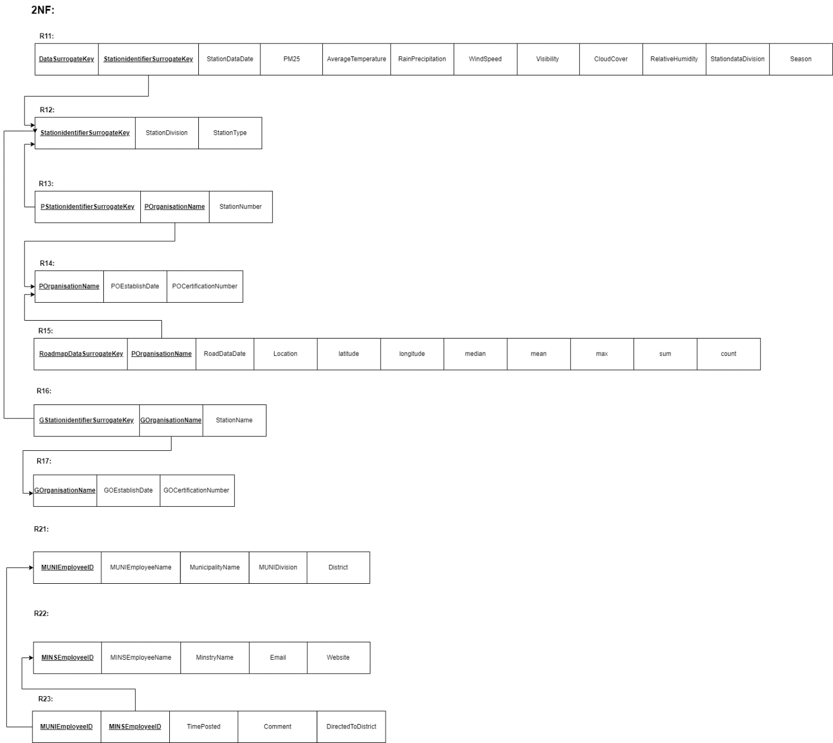

Figure 3.4: Normalization (till 2NF)

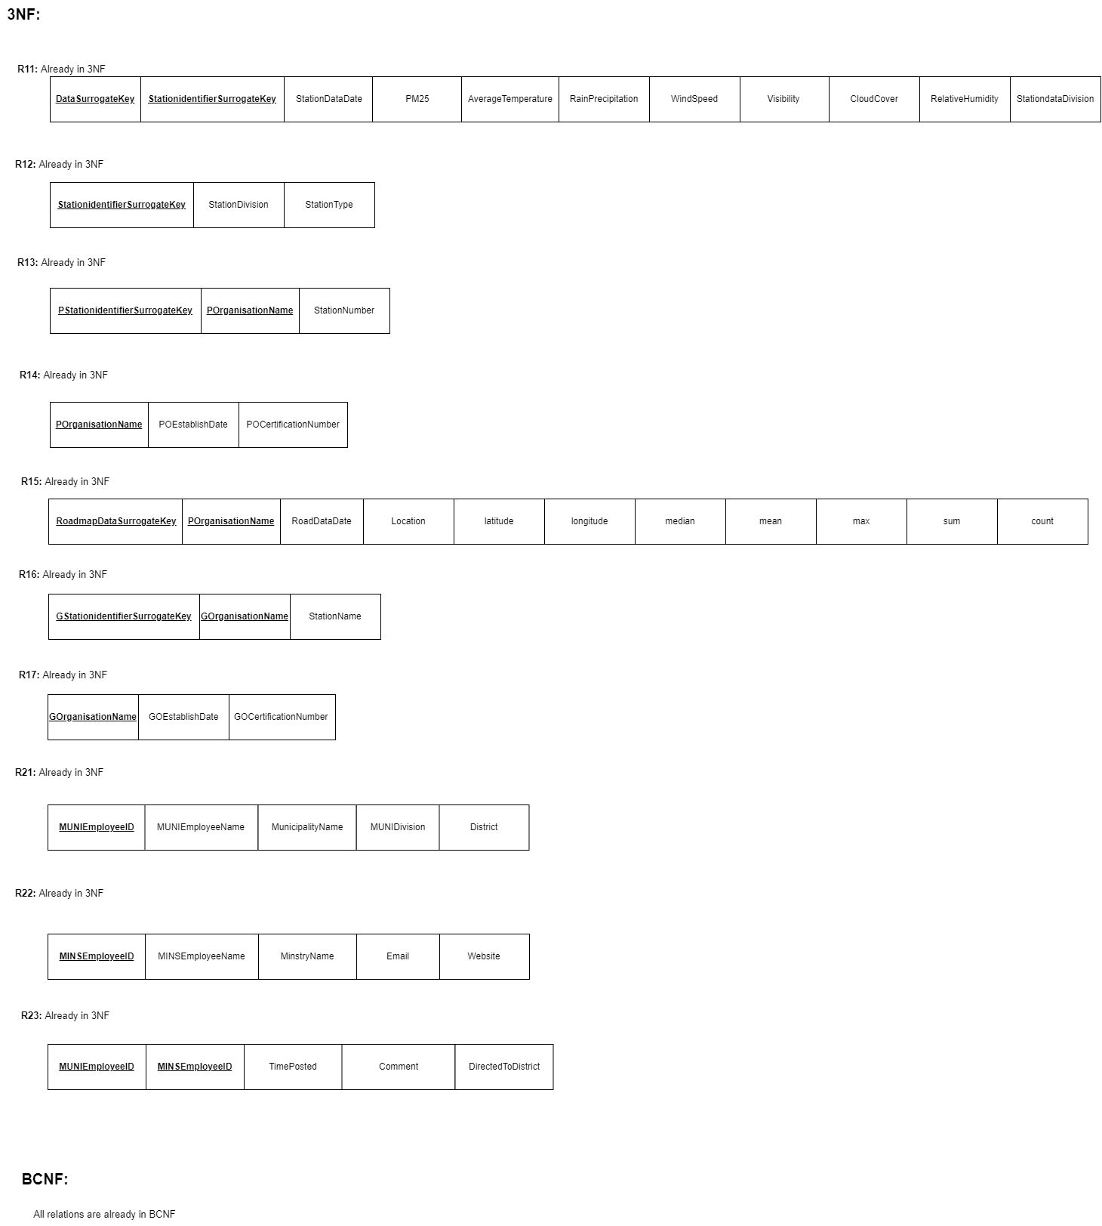

Figure 3.5: Normalization (till BCNF)

## **SECTION 3.5: DATA DICTIONARY**

**tblSTATIONDATA**

|  |  |  |  |
| --- | --- | --- | --- |
| **Name** | **Data Type** | **Size** | **Remark** |
| DataSurrogateKey | AUTO_INCREMENT | N/A | This is the primary key of this table which will be auto generated. |
| StationidentifierSurrogateKey | AUTO_INCREMENT | N/A | This is the foreign key of this table referencing the station table. This is also the partial identifier of this table. |
| StationDataDate | DATE | YYYY-MM-DD | This attribute contains the date of the data when it was collected. Example: 2020/01/01 |
| PM25 | DOUBLE | 4,1 | This attribute contains one of the parameter of the weather data. Example: 231.5. |
| AverageTemperature | DOUBLE | 3,1 | This attribute contains the date wise average temperature. Example: 20.5 |
| RainPrecipitation | DOUBLE | 4,1 | This attribute contains the date wise rain precipitation of the area. Example: 0 |
| WindSpeed | DOUBLE | 4,1 | This attribute contains the average daily wind speed. Example: 6.9 |
| Visibility | DOUBLE | 2 | This attribute contains the daily average visibility. Example: 1.2 |
| CloudCover | DOUBLE | 4,1 | This attribute contains the daily average cloud cover. Example: 16.3 |
| RelativeHumidity | DOUBLE | 5,2 | This attribute contains the daily relative humidity which is one of the parameter of air. Example: 73.17 |
| StationdataDivision | VARCHAR | 15 | This attribute contains the division from where the data is collected. Example: “Rangpur” |
| Season | VARCHAR | 10 | This attribute contains the season of the year when the data was collected. Example: “Winter” |

**tblSTATION**

|  |  |  |  |
| --- | --- | --- | --- |
| **Name** | **Data Type** | **Size** | **Remark** |
| StationidentifierSurrogateKey | AUTO_INCREMENT | N/A | This is the primary key of this relation which is auto incremented. |
| StationDivision | VARCHAR | 15 | This attribute contains the division where the station is situated. Example: “Rangpur” |
| StationType | VARCHAR | 20 | This attribute contains the type of the station, whether it is a private organization’s station or government organization’s station. Example: “Private” |

**tblPRIVATESTATION**

|  |  |  |  |
| --- | --- | --- | --- |
| **Name** | **Data Type** | **Size** | **Remark** |
| PStationidentifierSurrogateKey | AUTO_INCREMENT | N/A | This is the primary key of this relation which is auto incremented. |
| POrganisationName | VARCHAR | 20 | This attribute contains the name of the private organizations. This is a foreign key in this table which references to the research organization table. This is also a partial identifier of this table. Example: “PurpleAir” |
| StationNumber | INTEGER | 5 | This attribute contains the number of the station. Example: 18 |

**tblRESEARCHORGANISATION**

|  |  |  |  |
| --- | --- | --- | --- |
| **Name** | **Data Type** | **Size** | **Remark** |
| POrganisationName | VARCHAR | 20 | This is the primary key of this relation. This attribute contains the name of the private organization. Example: “EPA” |
| POEstablishDate | DATE | YYYY-MM-DD | This attribute contains the date of the establishment of the private organization. Example: “1999/04/01” |
| POCertificationNumber | VARCHAR | 20 | This attribute contains the certification number or the license number of the private organization. Example: “4362” |

**tblROADMAPDATA**

|  |  |  |  |
| --- | --- | --- | --- |
| **Name** | **Data Type** | **Size** | **Remark** |
| RoadmapDataSurrogateKey | AUTO_INCREMENT | N/A | This is the primary key of this relation which is auto incremented. |
| POrganisationName | VARCHAR | 20 | This attribute contains the name of the private organization. This is a foreign key in this relation referencing the research organization table. Example: “IQAir” |
| RoadDataDate | DATE | YYYY-MM-DD | This attribute contains the date when the road map data was collected. Example: “2017/11/24” |
| Location | VARCHAR | 15 | This attribute contains the location where the data were collected. Example: “Ukrainian Village” |
| Latitude | DOUBLE | 9,6 | This attribute contains the latitude of the point where the data were collected. Example: 41.89227 |
| Longitude | DOUBLE | 9,6 | This attribute contains the longitude of the point where the data were collected. Example:  -87.6856 |
| Median | DOUBLE | 12,9 | This attribute contains the daily median of the data collected. Example: 3.02 |
| Mean | DOUBLE | 12,9 | This attribute contains the daily mean of the data collected. Example: 2.867143 |
| Max | DOUBLE | 12,9 | This attribute contains the daily max of the data collected. Example: 5.05 |
| sum | DOUBLE | 12,9 | This attribute contains the daily summation of the data that were collected. Example: 20.07 |
| Count | INTEGER | 5 | This attribute contains how many data were collected daily. Example: 7 |

**tblGOVERNMENTSTATION**

|  |  |  |  |
| --- | --- | --- | --- |
| **Name** | **Data Type** | **Size** | **Remark** |
| GStationidentifierSurrogateKey | AUTO_INCREMENT | N/A | This is the primary key of this table which is auto generated. |
| GOrganisationName | VARCHAR | 20 | This attribute contains the name of the government organization. This is a foreign key of this table which references to the government organization table. This is one of the partial identifier of this table. |
| StationName | VARCHAR | 20 | This attribute contains the name of the station. Example: “RangpurRamu” |

**tblGOVERNMENTORGANISATION**

|  |  |  |  |
| --- | --- | --- | --- |
| **Name** | **Data Type** | **Size** | **Remark** |
| GOrganisationName | VARCHAR | 20 | This attribute contains the name of the government organization. This is also the primary key of this relation. Example: “Bangladesh Weather Ministry” |
| GOEstablishDate | DATE | YYYY-MM-DD | This attribute contains the establishment date of the government organization. Example: 1989/01/02 |
| GOCertificationNumber | VARCHAR | 20 | This attribute contains the certification number of the government organization. Example: 6789053467 |

**tblMUNICIPALITYEMPLOYEE**

|  |  |  |  |
| --- | --- | --- | --- |
| **Name** | **Data Type** | **Size** | **Remark** |
| MUNIEmployeeID | INTEGER | 7 | This attribute contains the ID of the employee of the municipality. This is the primary key of this relation. Example: 5002 |
| MUNIEmployeeName | VARCHAR | 50 | This attribute contains the name of the employee who works for the municipality. Example: “Jakir” |
| MunicipalityName | VARCHAR | 50 | This attribute contains the name of the municipality. Example: “City Corporation North” |
| MUNIDivision | VARCHAR | 15 | This attribute contains the division where the municipality is situated. Example: “Dhaka” |
| District | VARCHAR | 20 | This attribute contains the district where the municipality is situated. Example: “Dhaka” |

**tblPOLICYCOMMENT**

|  |  |  |  |
| --- | --- | --- | --- |
| **Name** | **Data Type** | **Size** | **Remark** |
| MINSEmployeeID | INTEGER | 7 | This attribute contains the ID of the employee who works for the ministry. This is foreign key of this relation which references to the ministry official table. This is one of the primary keys of this relation. Example: 2022002 |
| MUNIEmployeeID | INTEGER | 7 | This attribute contains the ID of the employee who works for the municipality. This is a foreign key of this relation which references to the municipality employee table. This is one of the primary key of this relation. Example: 5002 |
| TimePosted | DATE | YYYY-MM-DD | This attribute contains the date when the comment was posted by the user. Example: 2022/08/26 |
| Comment | LONGTEXT | N/A | This attribute contains the comment input by the user. |
| DirectedToDistrict | VARCHAR | 20 | This attribute contains the name of the district for which the comment was directed to. Example: “Dhaka” |

**tblMINISTRYOFFICIAL**

|  |  |  |  |
| --- | --- | --- | --- |
| **Name** | **Data Type** | **Size** | **Remark** |
| MINSEmployeeID | INTEGER | 7 | This attribute contains the ID of the employee who works for the ministry. This is the primary key of this relation. Example: 2022002 |
| MINSEmployeeName | VARCHAR | 50 | This attribute contains the name of the employee who works for the ministry. Example: “Ridwan” |
| MinstryName | VARCHAR | 50 | This attribute contains the name of the ministry. Example: “Bangladesh Weather Ministry” |
| Email | VARCHAR | 50 | This contains the email of the employees who work for the ministry. Example: “ridwan@gmail.com” |
| Website | VARCHAR | 50 | This attribute contains the website link of the ministry. |

# **CHAPTER 4: PHYSICAL SYSTEM DESIGN**

## **SECTION 4.1: INPUT FORMS**

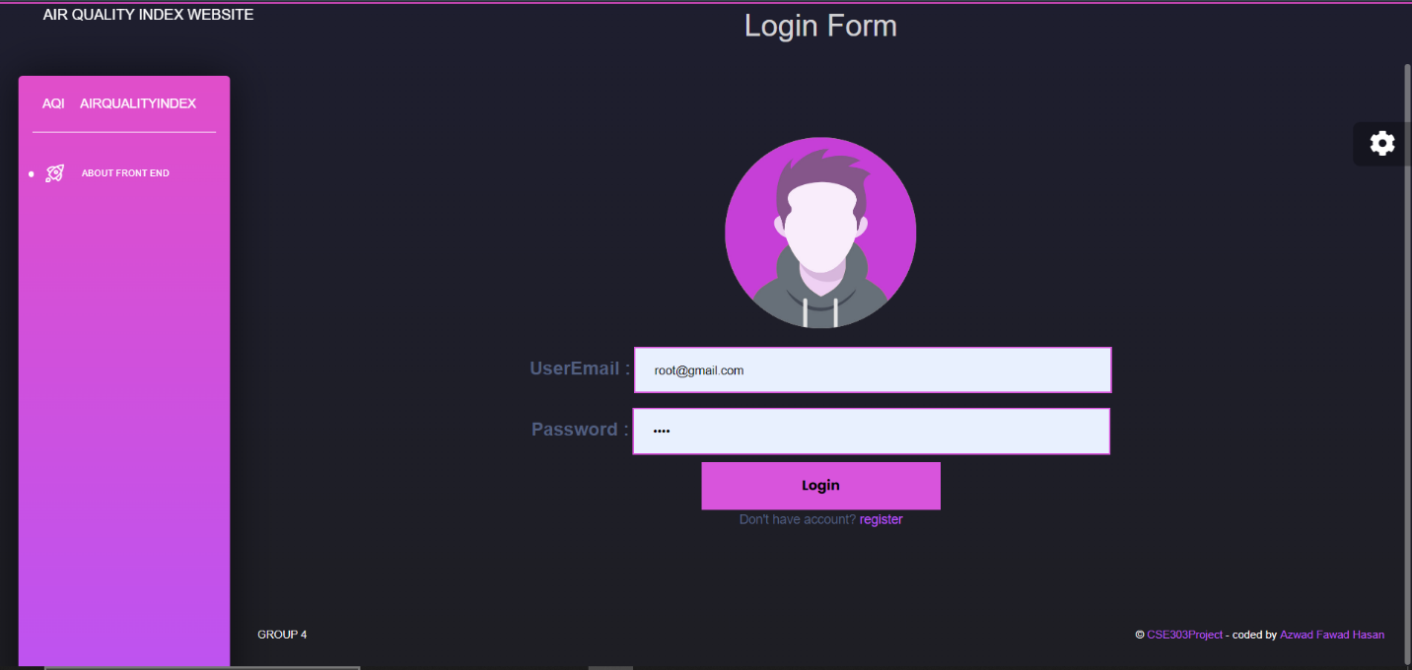

Figure 4.1: Login Page of the AQMS website

**Code:**

if request.method == "POST":

mysqlObject = sql.connect(

host="localhost",

user="root",

password ="root",

database='air'

)

cursor = mysqlObject.cursor();

dataFromForm=request.POST

for key, value in dataFromForm.items():

if key =="email":

emailVar=value;

if key =="password":

passwordVar=value;

getFromDatabase ="select * from users where email='{}' and password ='{}'".format(emailVar,passwordVar)

cursor.execute(getFromDatabase); #executing query

storingDataFromDbInATuple = (cursor.fetchall())

adminQuery = "select * from users where email='root@gmail.com' and password ='root'".format(emailVar,passwordVar);

cursor.execute(adminQuery);

storingAdminQuery = (cursor.fetchall())

if storingDataFromDbInATuple==():

return render(request, 'error.html');

if storingDataFromDbInATuple==(storingAdminQuery):

return render(request,'adminHomepage.html')

else:

return render(request, 'welcome.html');

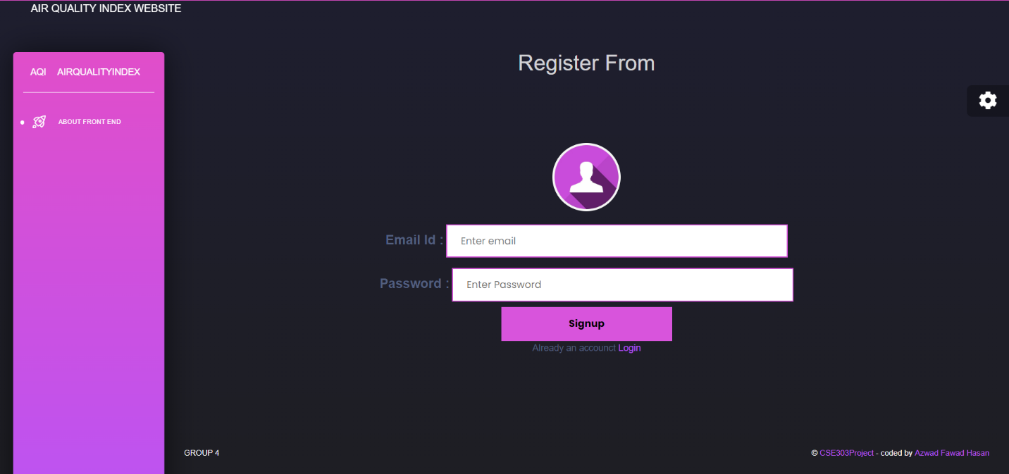

Figure 4.2: Registration Form of the AQMS website

**Code:**

if request.method == "POST":

mysqlObject = sql.connect(

host="localhost",

user="root",

password ="root",

database='air'

)

cursor = mysqlObject.cursor();

dataFromForm=request.POST

for key, value in dataFromForm.items():

if key =="email":

emailVar=value;

if key =="password":

passwordVar=value;

saveInDatabase ="insert into users Values('{}','{}')".format(emailVar,passwordVar)

cursor.execute(saveInDatabase); #executing query

mysqlObject.commit();#saves info in mysql server

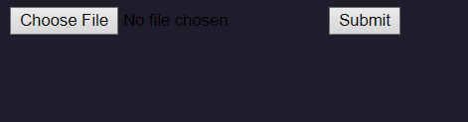

Figure 4.3: CSV file upload sector for AQI data input by the admin

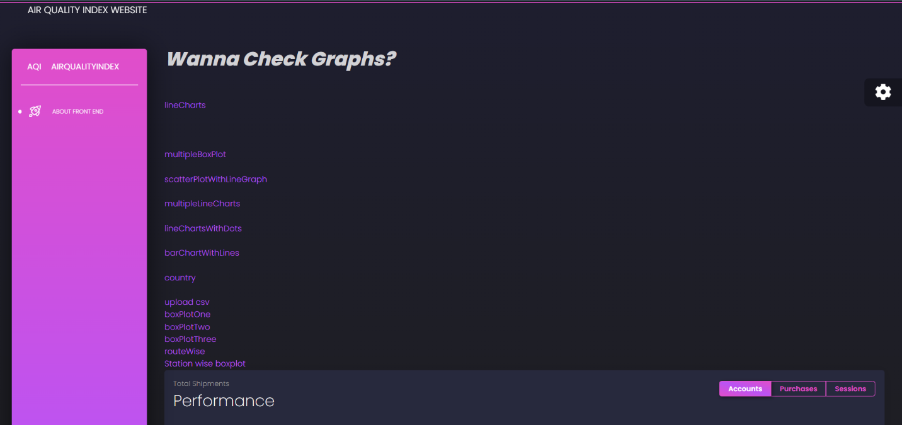

Figure 4.4: Admin Dashboard

## **SECTION 4.2: OUTPUT FORMS**

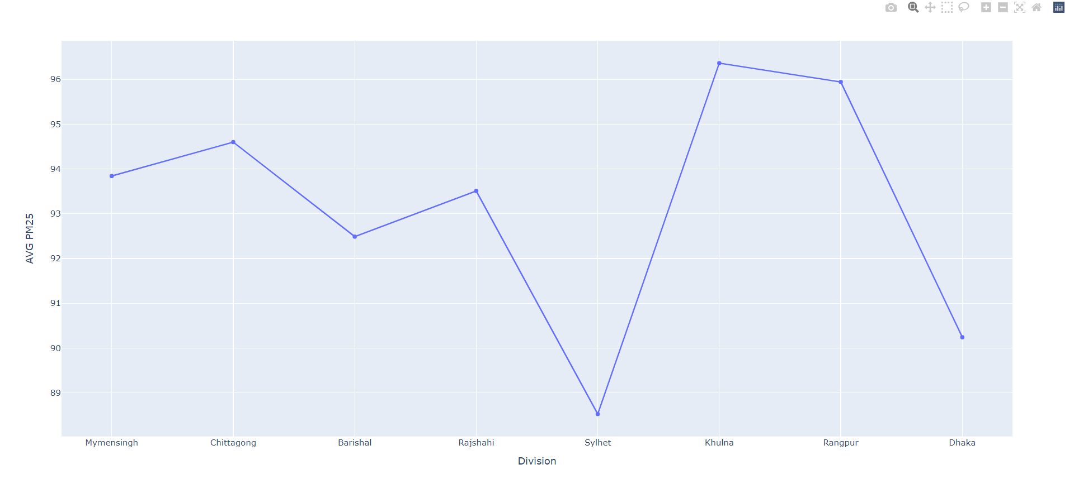

Figure 4.5: AVG PM25 against Division line chart

**Code:**

db_name = "air"

db_host = "localhost"

db_username = "root"

db_password = "root"

try:

conn=pymysql.connect(host =db_host,

port = int(3306),

user = db_username,

passwd = db_password,

db=db_name)

except e:

print(e)

#Division-Wise daily AQI data visualization using line charts, e.g.

df = pd.read_sql_query("SELECT * FROM finaltraindata", conn

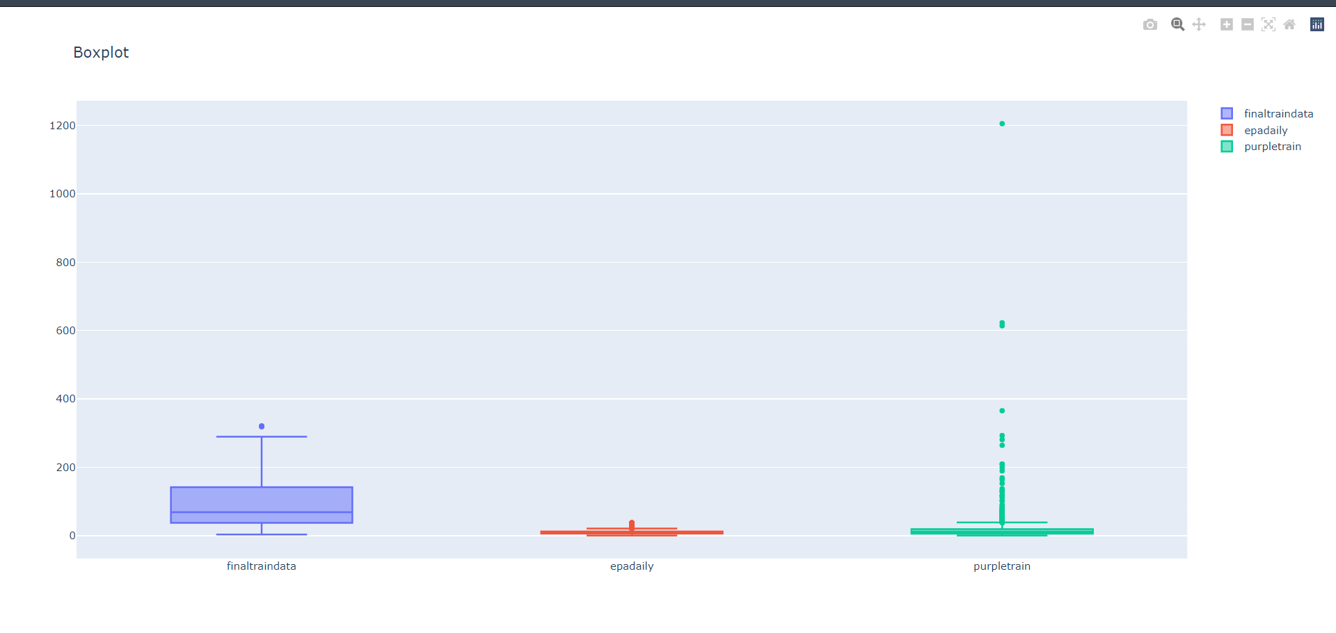

Figure 4.6: Box Plot organization wise

**Code:**

db_name = "air"

db_host = "localhost"

db_username = "root"

db_password = "root"

try:

conn=pymysql.connect(host =db_host,

port = int(3306),

user = db_username,

passwd = db_password,

db=db_name)

except e:

print(e)

df = pd.read_sql_query("SELECT * FROM epadaily", conn)

df2 = pd.read_sql_query("SELECT * FROM purpleair", conn)

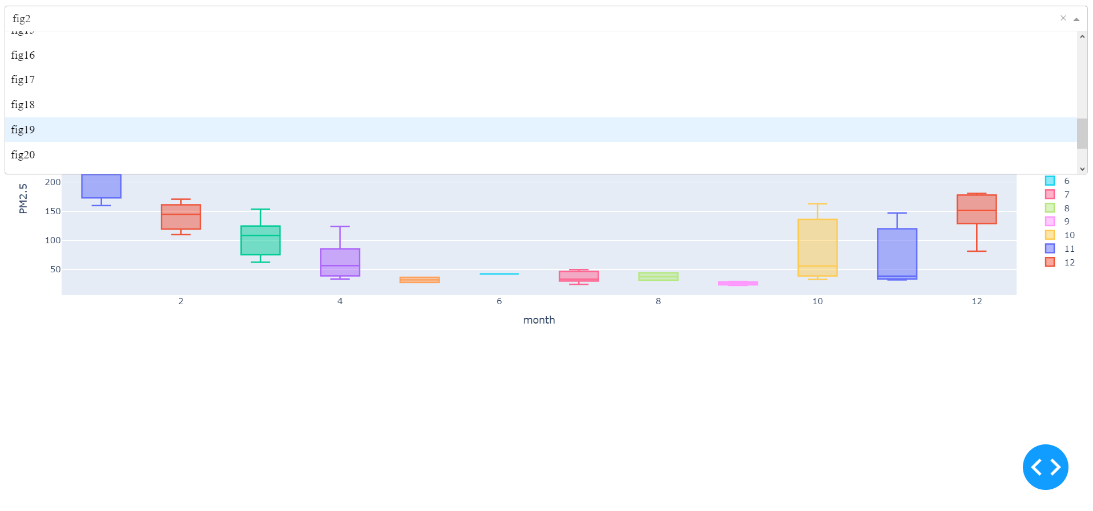

Figure 4.7: Box Plot of each station using dropdown and boxplot shows PM 2.5

**Code:**

db_name = "air"

db_host = "localhost"

db_username = "root"

db_password = "root"

try:

conn=pymysql.connect(host =db_host,

port = int(3306),

user = db_username,

passwd = db_password,

db=db_name)

except e:

print(e)

df = pd.read_sql_query("SELECT * FROM finaltraindata", conn)

df1 = pd.read_sql_query("SELECT * FROM epadaily", conn)

df2 = pd.read_sql_query("SELECT * FROM purpleair", conn)

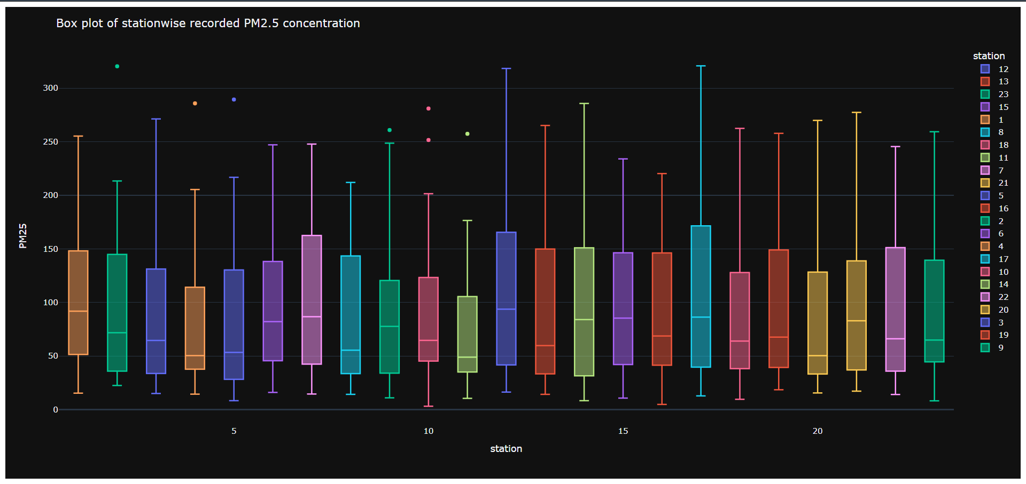

Figure 4.8: Box Plot of PM 2.5 against stations separated by station numbers

**Code:**

db_name = "air"

db_host = "localhost"

db_username = "root"

db_password = "root"

try:

conn=pymysql.connect(host =db_host,

port = int(3306),

user = db_username,

passwd = db_password,

db=db_name)

except e:

print(e)

df = pd.read_sql_query("SELECT * FROM finaltraindata", conn)

df1 = pd.read_sql_query("SELECT * FROM epadaily", conn)

df2 = pd.read_sql_query("SELECT * FROM purpleair", conn)

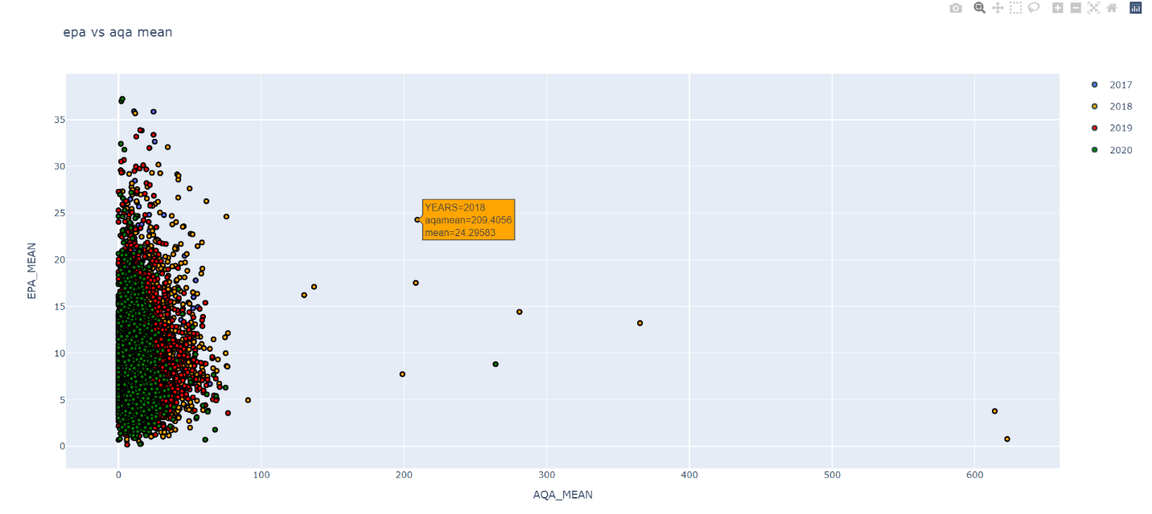

Figure 4.9: Scatter Plot EPA mean against IQAir mean distinguished by years

**Code:**

db_name = "air"

db_host = "localhost"

db_username = "root"

db_password = "root"

try:

conn=pymysql.connect(host =db_host,

port = int(3306),

user = db_username,

passwd = db_password,

db=db_name)

except e:

print(e)

df = pd.read_sql_query("SELECT * FROM epadaily", conn)

df2 = pd.read_sql_query("SELECT * FROM purpleair", conn)

yiq-qywd-jjo

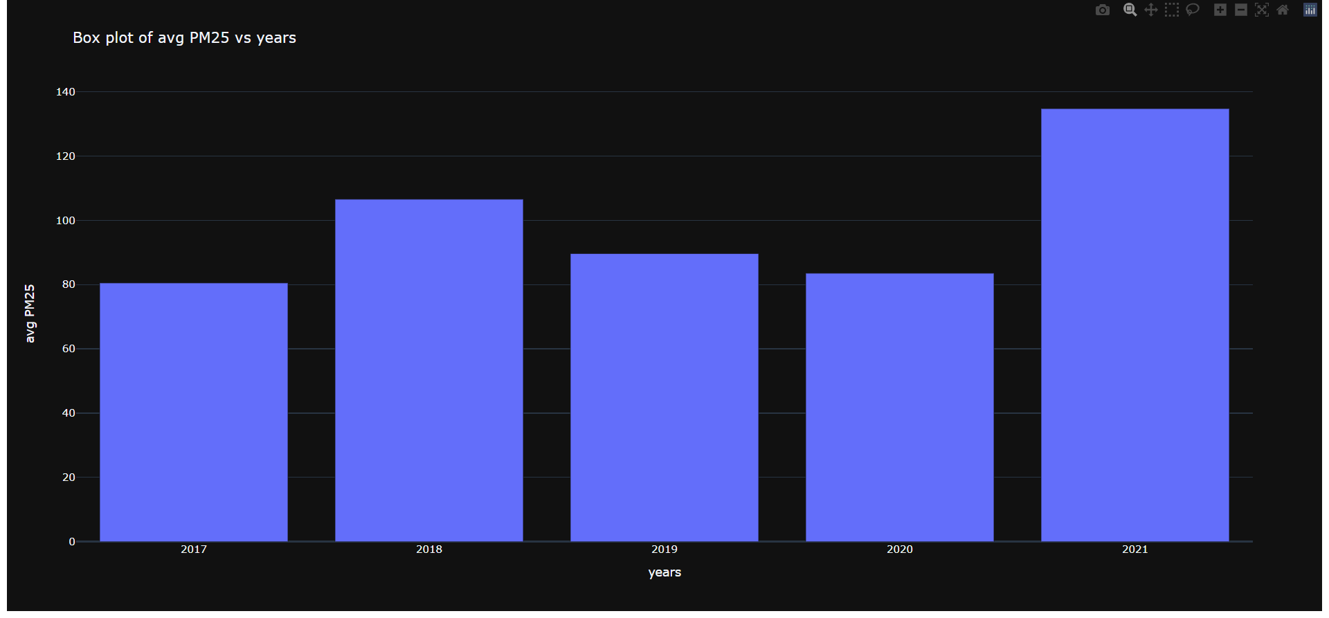

Figure 4.10: Bar graph of average PM2.5 against year

**Code:**

db_name = "air"

db_host = "localhost"

db_username = "root"

db_password = "root"

try:

conn=pymysql.connect(host =db_host,

port = int(3306),

user = db_username,

passwd = db_password,

db=db_name)

except e:

print(e)

df = pd.read_sql_query("SELECT * FROM finaltraindata", conn)

yiq-qywd-jjo

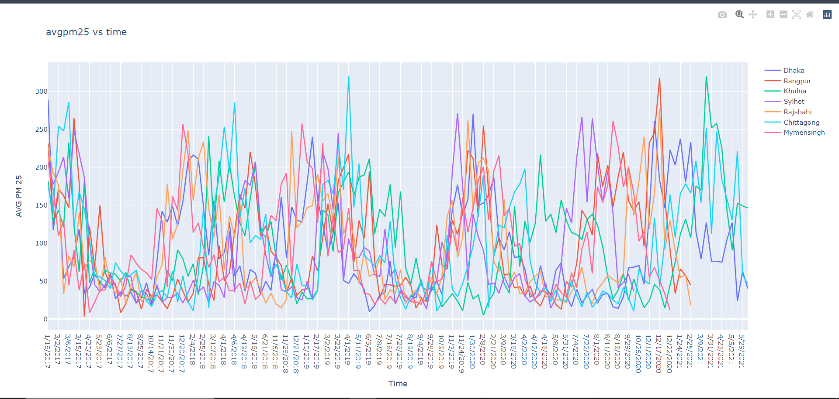

Figure 4.11: Average PM2.5 against time graph

**Code:**

db_name = "air"

db_host = "localhost"

db_username = "root"

db_password = "root"

try:

conn=pymysql.connect(host =db_host,

port = int(3306),

user = db_username,

passwd = db_password,

db=db_name)

except e:

print(e)

#Division-Wise daily AQI data visualization using line charts, e.g.

df = pd.read_sql_query("SELECT * FROM finaltraindata", con

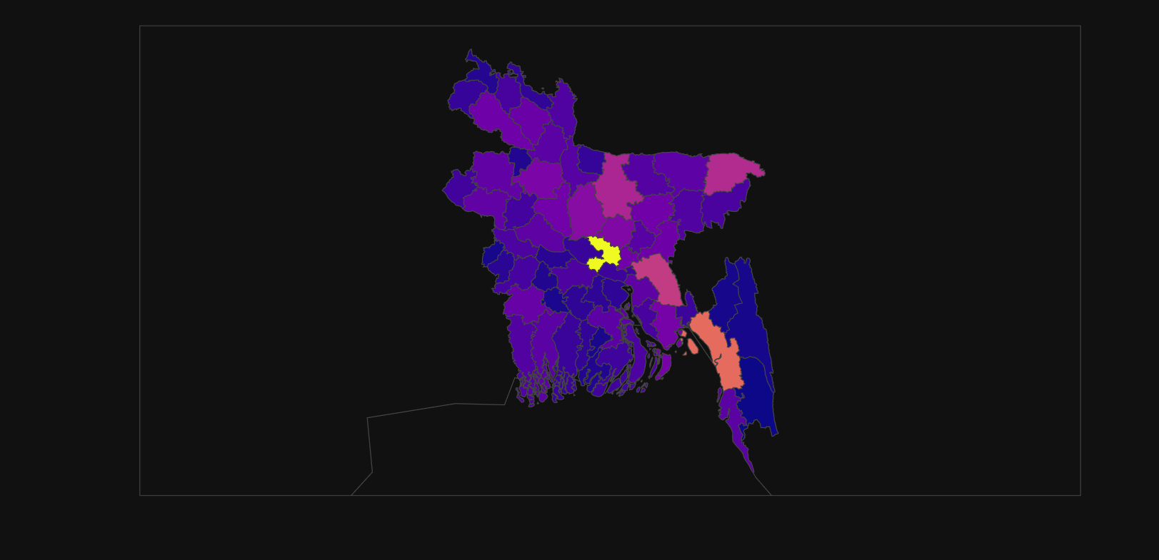

Figure 4.12: Map of Bangladesh based on AQI data

**Code:**

bd_districts=load(open('graphs/bangladesh_geojson_adm2_64_districts_zillas.json','r'))

df=pd.read_csv("graphs/Districts_of_Bangladesh.csv")

df.District = df.District.apply(lambda x: x.replace(" District",""))

district_id_map = {}

for feature in bd_districts["features"]:

feature["id"] = feature["id"]

district_id_map[feature["properties"]["ADM2_EN"]] = feature["id"]

df['id'] = df.District.apply(lambda x: district_id_map[x])

df = df.rename(columns={

'Population (thousands)[28]' : 'Population (thousands)',

'Area (km2)[28]' : 'Area (km2)' })

fig = px.choropleth(

df,

locations='id',

geojson=bd_districts,

color='Population (thousands)',

title='Bangladesh Population',

)

fig.update_geos(fitbounds="locations", visible=True)

fig.show()

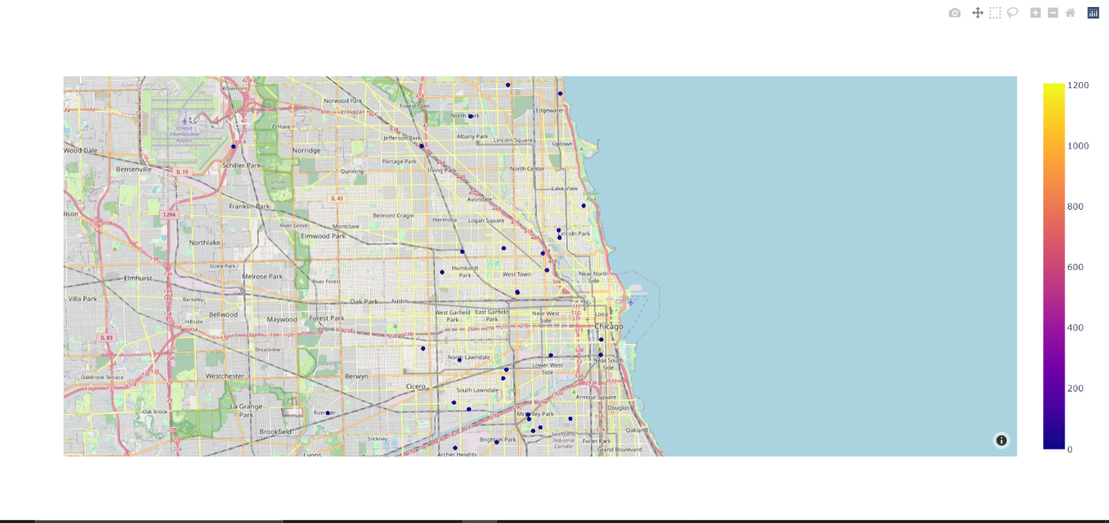

Figure 4.13: Routine wise mapping

**Code:**

db_name = "air"

db_host = "localhost"

db_username = "root"

db_password = "root"

try:

conn=pymysql.connect(host =db_host,

port = int(3306),

user = db_username,

passwd = db_password,

db=db_name)

except e:

print(e)

#df = pd.read_sql_query("SELECT * FROM finaltraindata", conn)

df2 = pd.read_sql_query("SELECT * FROM epadaily", conn)

df3 = pd.read_sql_query("SELECT * FROM purpleair", conn)

# **CHAPTER 5: CONCLUSION**

## **SECTION 5.1: PROBLEM AND SOLUTION**

1. There is not much of information in the internet about the data of the air quality of Bangladesh except from the government website. Using the limited amount of data given by our instructor, we have completed the project.
2. We have heard about the project for the first time from our faculty member, it took a very long time for us to get to know about what the project was about. The required information for the project was given by our instructor.

## **SECTION 5.2: ADDITIONAL FEATURE AND FUTURE DEVELOPMENT**

1. An in-built function can be integrated which will automatically store the previous generated reports in the AQM system, which can be used later to analyze the reports through years.
2. Rebuilt the report generation module in such a way that the AQM system user can choose templates of how they want to see the reports.
3. Incorporate an AI system which will give feedbacks automatically of what to do after analyzing the reports generated by AQM system.
4. An in-build function in the AQM system can be integrated, which will automatically convert the measurement unit into a standardized measurement unit of the data in the AQM system.
5. An in-built module can be incorporated in the AQM system which will convert any form of files into CSV format for data input sector.
6. An in-built module can be incorporated in the AQM system which will translate the files which are in Bangla to English for data input sector.

## **SECTION 5.3: CONCLUSIONS AND RECOMMENDATIONS**

Since Bangladesh is a developing country, industrialization and modernization is increasing day by day. And with all these development process, pollution is increasing. According to IQAir research, Bangladesh has the worst air quality in the entire world (Air quality in Bangladesh, n.d.). This is a very big issue to be concerned of. In order to find a solution for this, we have prepared an Air Quality Monitoring System (AQMS). This will help the government, organizations and other environmental analysts to monitor the air quality of the country. From our proposed solution, the individuals who deals with environment will get different types of atmospheric maps and graphs from the input data. From these reports of the air quality, the government can give feedbacks and take necessary initiatives to make Bangladesh a better place to live.

# References

*Air quality in Bangladesh*. (n.d.). Retrieved from IQAir: https://www.iqair.com/bangladesh